**Tut sheet I**

**1.Implement any transformation (Affine, Euclidean, orthogonal)**

**AFFINE TRANSFORMATION-**

import cv2

import numpy as np

from matplotlib import pyplot as plt

img = cv2.imread('food.jfif')

rows, cols, ch = img.shape

pts1 = np.float32([[50, 50],

[200, 50],

[50, 200]])

pts2 = np.float32([[10, 100],

[200, 50],

[100, 250]])

M = cv2.getAffineTransform(pts1, pts2)

dst = cv2.warpAffine(img, M, (cols, rows))

plt.subplot(121)

plt.imshow(img)

plt.title('Input')

plt.subplot(122)

plt.imshow(dst)

plt.title('Output')

plt.show()

while(1):

cv2.imshow('image', img)

if cv2.waitKey(20) & 0xFF == 27:

break

cv2.destroyAllWindows()

**OUTPUT-**

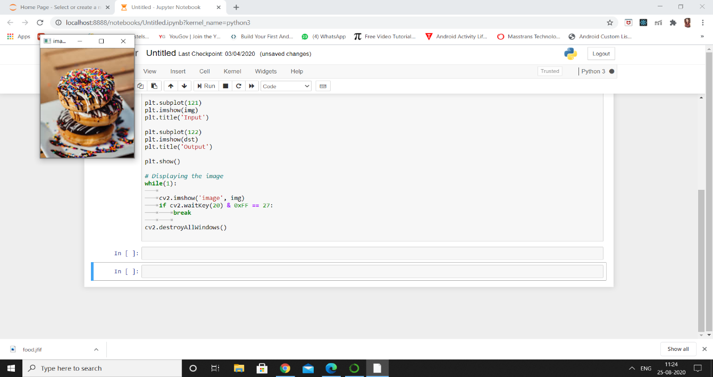

**2. Implement any two filters to blur and smoothen the image showing differences obtained.**

## **2D Convolution ( Image Filtering )**

import cv2

import numpy as np

from matplotlib import pyplot as plt

img = cv2.imread('images.png')

kernel = np.ones((5,5),np.float32)/25

dst = cv2.filter2D(img,-1,kernel)

plt.subplot(121),plt.imshow(img),plt.title('Original')

plt.xticks([]), plt.yticks([])

plt.subplot(122),plt.imshow(dst),plt.title('Averaging')

plt.xticks([]), plt.yticks([])

plt.show()

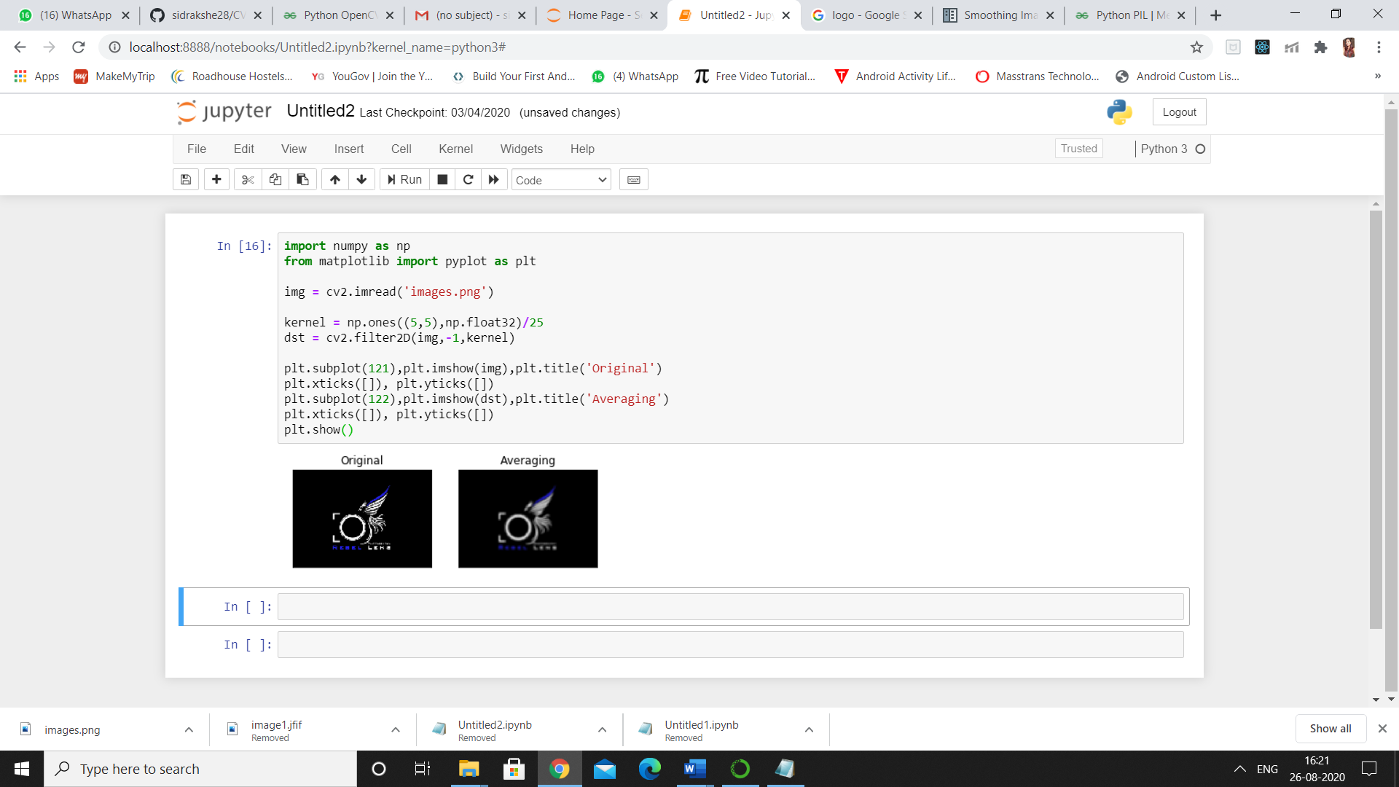

## **Image Blurring (Image Smoothing)**

### 1. Averaging

import cv2

import numpy as np

from matplotlib import pyplot as plt

img = cv2.imread('opencv_logo.png')

blur = cv2.blur(img,(5,5))

plt.subplot(121),plt.imshow(img),plt.title('Original')

plt.xticks([]), plt.yticks([])

plt.subplot(122),plt.imshow(blur),plt.title('Blurred')

plt.xticks([]), plt.yticks([])

plt.show()

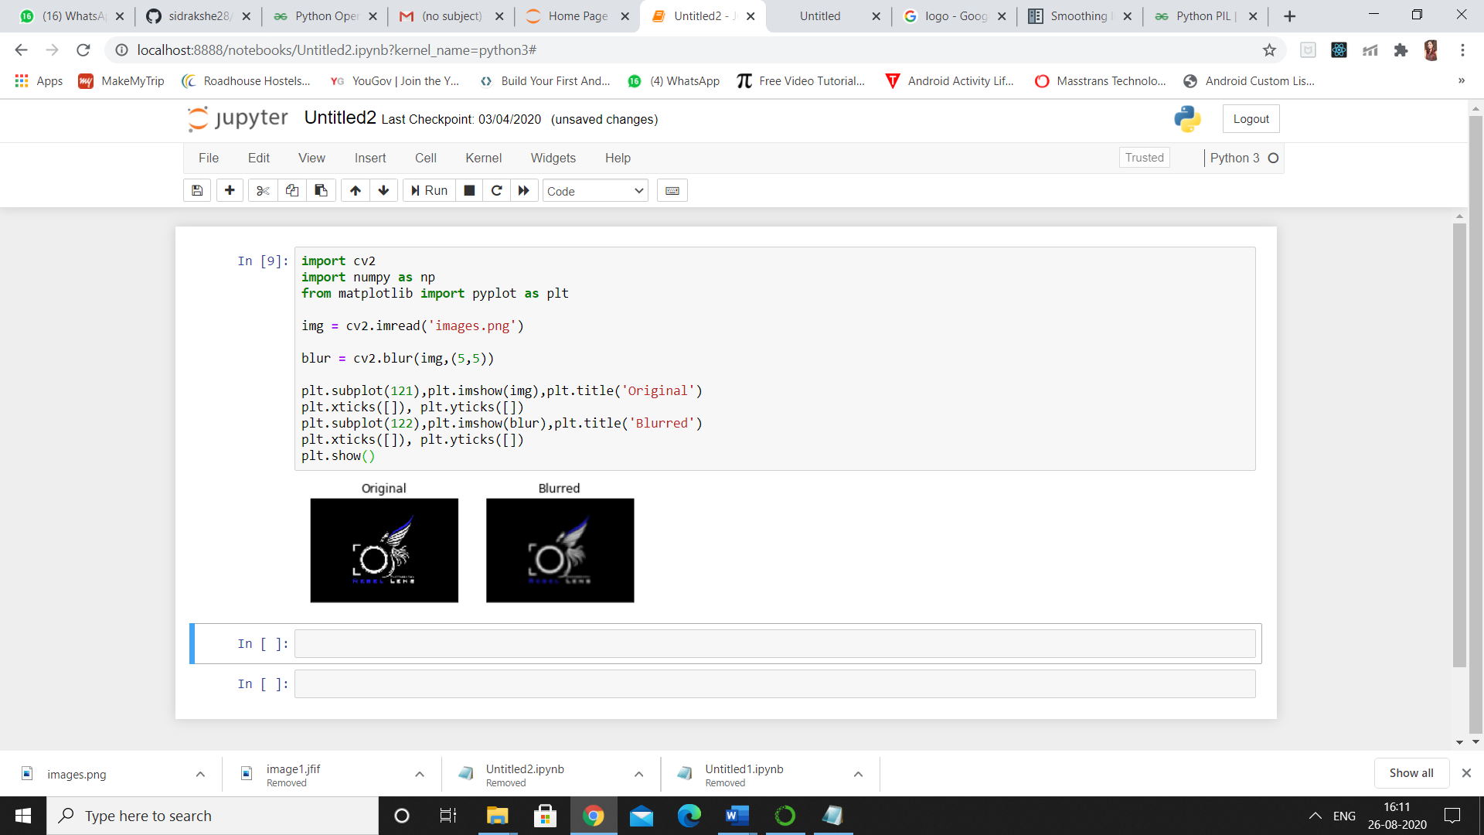

### 2. Gaussian Filtering

import cv2

import numpy as np

from matplotlib import pyplot as plt

img = cv2.imread('opencv_logo.png')

blur = cv2.GaussianBlur(img,(5,5),0)

plt.subplot(121),plt.imshow(img),plt.title('Original')

plt.xticks([]), plt.yticks([])

plt.subplot(122),plt.imshow(blur),plt.title('Blurred')

plt.xticks([]), plt.yticks([])

plt.show()

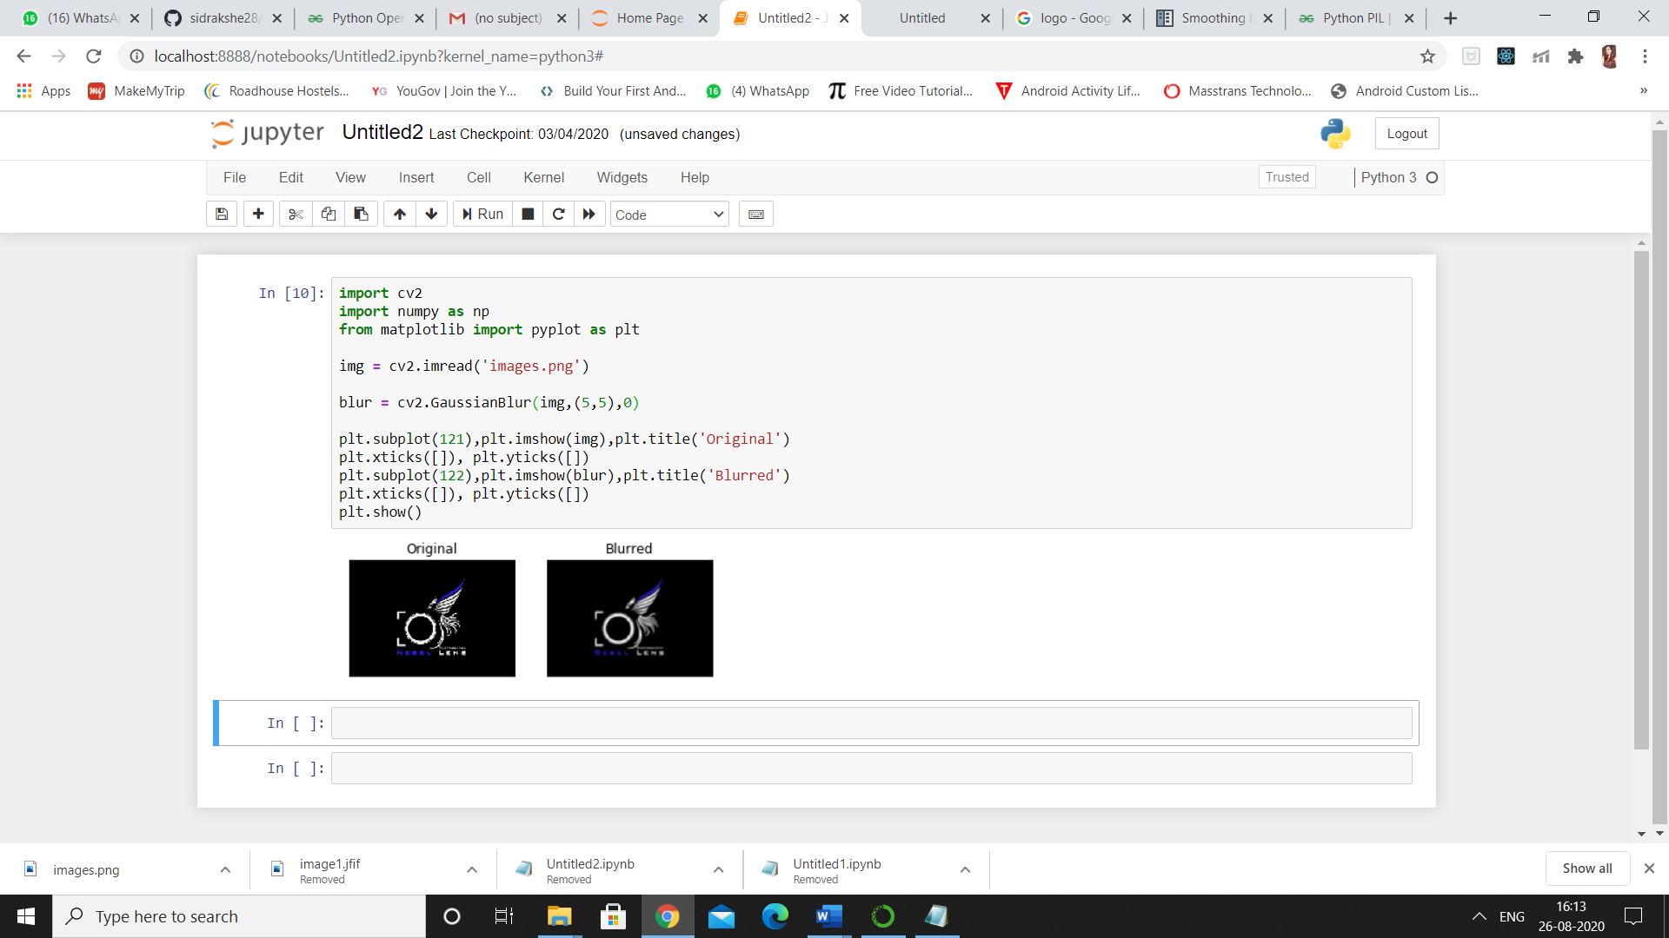

### 3.  Bilateral Filtering

import cv2

import numpy as np

from matplotlib import pyplot as plt

img = cv2.imread('opencv_logo.png')

blur = cv2.bilateralFilter(img,9,75,75)

plt.subplot(121),plt.imshow(img),plt.title('Original')

plt.xticks([]), plt.yticks([])

plt.subplot(122),plt.imshow(blur),plt.title('Blurred')

plt.xticks([]), plt.yticks([])

plt.show()

### 